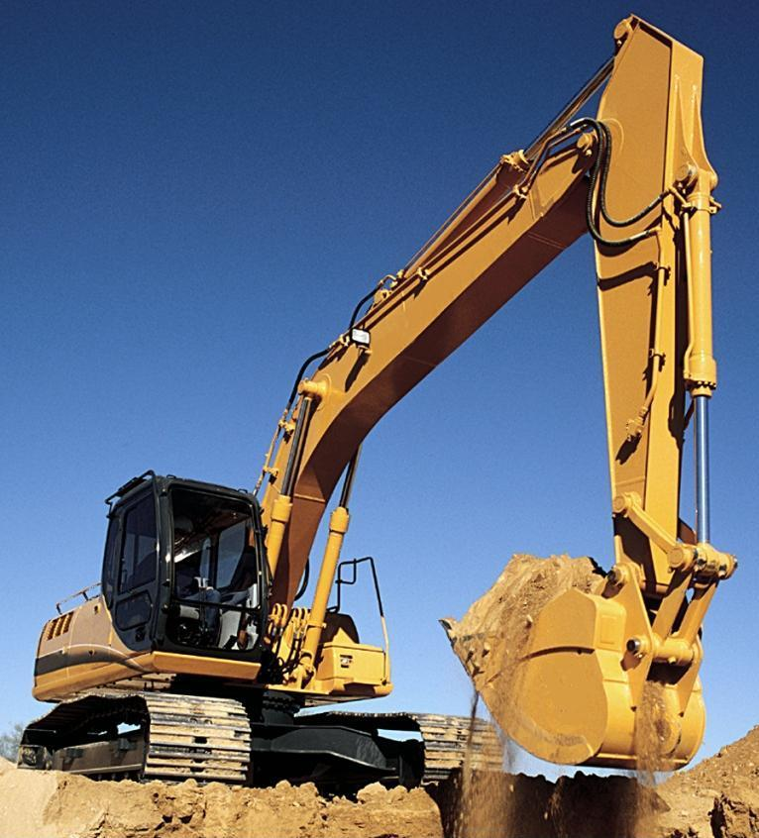

The staff at Terrappe Group advised that he should use the TEXXON XHD Red grease as it has a very high temperature resistance with no squeeze out and is suitable to use as a general purpose grease throughout most excavators. With oxidation inhibited Terrappe Groups TEXXON HD Red grease guarantees long service life.

**The Terrappe Solution**

Crotty's Excavation used a lithium grease throughout their fleet of machinery. The owner noticed in the hot weather that the grease appeared to melt and leak out of the joints. This not only made the machine look dirty it showed that the grease was unable to carry out the job of minimizing wear in extreme conditions.

**The Challenge**

*Following the period of flushing the old grease from the joint the operator was very pleased to see a massive reduction in the grease consumption and no apparent oil leakage from the pin and bush joint. Andrew mentioned that "we went from using 10 pumps of grease each day in the main boom pin down to 5 or less"*

* *Andrew (Crotty’s Excavation)*

Excavator reduces grease volume by 50%